*****Test Management Process***** is a set of activities from the start of the testing to the end of the testing. It gives a discipline to testing. When follow a test process it gives us the plan at the initial. Test process provides the facility to plan and control the testing throughout the project cycle. It helps to track and monitor the testing throughout the project. Provides transparent of testing among stakeholders and maintains the conducted test for future reference. Affords deep level of detail of the testing that’s being carrying out. Gives clear understanding of testing activities of prior project and post project to all the stakeholders.There are many tools (Tools such as qTest, JIRA, Team Service, TestLink.) available to manage the test process. Test process can be defined and practiced differently according to the necessity in test. Explained below are the typical activities in test process.

* ****Project manager**** - sets tasks and checks work progress:
  + Sets task to ****Analyst**** to break up ****Change request**** to ****Detail requirements****, that are well manageable from the perspective of development and following testing.
  + Sets task to ****Test manager**** to choose those ****test cases**** from the catalogue, that verify meeting requirements, and define new test cases, that enable testing newly developed functionalities.
  + Sets to ****Test manager**** to assign ****test cases**** in particular****test rounds**** to particular ****Testers****.
* ****Test manager**** - based on task from the project manager:
  + Identifies relevant ****test cases****, creates new necessary cases and introduces them into the test case catalogue.
  + Assigns test cases to ****Testers****.

****Testers**** perform test assigned to them acording to the definitions of ****test cases**** and report ****bugs****. Developers work bugs assigned to them for correction. After that developer indicates that the bug is corrected, there is a request automatically created for testing the test case, at which testing the bug was originally reported, and it is assigned to the tester, that reported the bug.

Since ****change requests**** are broken up to ****detailed requests****, to which ****test cases**** are assigned, Project manager can easily monitor testing progress and status of solving the reported bugs in relation to particular developed functionalities. This enables him to assess well readiness for the final UAT tests or release into production.

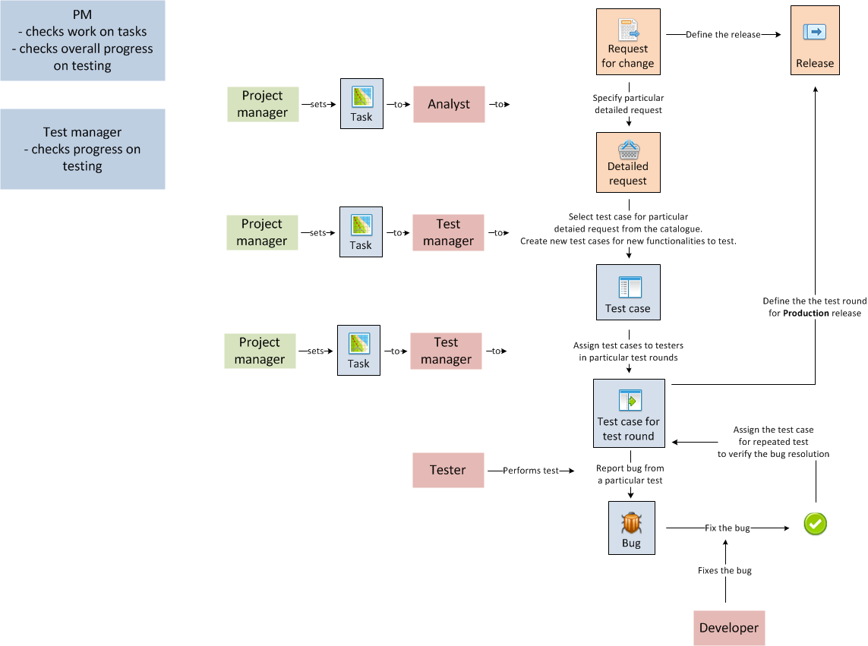

[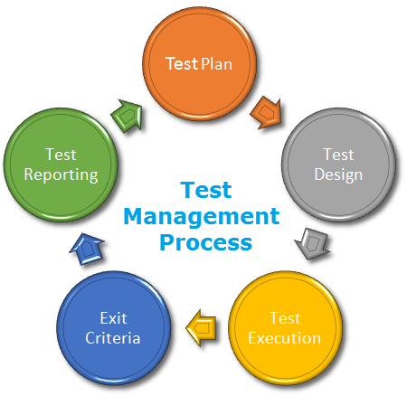](https://www.softwaretestingclass.com/wp-content/uploads/2017/03/Test-Management-process.png)

# ****1) Test Plan:****

Test plan served as an initial sketch to carry out the testing. Testing is being tracked and monitored as per the test plan. It gives a prior picture of test challenge and aspect that will be carried out for the software. By maintaining a test plan we can manage the changes in the plan.When starting new projects, based on the lesson learned in the previous tests, test plan needs to be improved to get betterment. Test plan explains the over view of particular requirement which needs to be tested, scope, functional and non-functional requirement, risk and mitigation, testing approaches, test schedule and deliverables and schedule, out of scope and assumption, test team and allocation, test environment, test activities mechanism and any other special note for testing.

[IMG_257](https://www.softwaretestingclass.com/wp-content/uploads/2017/03/test-process-plan.png)

|  |  |
| --- | --- |
| ****Test plan elements**** | ****Description**** |
| Over view | Over view of the test plan and purpose of this test plan. What’s the project that needs to be tested? Brief of the software that needs to be tested. Purpose of providing this software to user. |
| Scope and out of scope | What’s the purpose of the testing? What type of testing is going to be carried out?If there is any out of scope of testing. Brief explanation on the software project and what are covered in the test plan.Defining a frame to the testing based on resources, effort, budget and time line. What features or section that will be covered and what features or section will not be covered during the testing. |
| Functional and non-functional requirement | Explain each functional and non-fictional (performance testing, usability testing) testing that needs to be carried out. Explain each features that will be tested. Each functional and non-functional items should be placed without ambiguity. |
| Risk and mitigation | Explain the identified project, software and resources related risk. Explain the mitigation plan and possibility.Identify risk that we could face during the testing. Resource unavailability, delay in developer release, slip in schedule, less understanding in functions and gap between business and system requirement. |
| Testing approaches | What kind of testing approaches will be used? What type of testing will be carried out? Test types like installation testing, functional testing, UAT testing.Specify what tools we are going to use in testing. Specify the tools and license information that need for the testing. |
| Test schedule and deliverables | Describe entire star and complete date of testing. Need to find out the date of developer releases and number of releases. Mention each of the developer release date, test start date and completion date. Analyse the requirement and testing we are going to carry out and then come up with the effort. Based on the resource, plan the schedule with mile stone.  We also need to consider the time frame like any specific deadline. |
| Assumption | There can be any assumption related to software, project, resource or any concepts. And these have to be written in this. |
| Test team and allocations | Who are the testers that will be involved and what their responsibilities in the project are.To whom the training is required, if any. When responsibilities are set it’s easy to conduct the testing in project. |
| Test environment | Provide all the information related to test environment. What is the test environment? In which browsers the testing is carried out? Mentioning the UAT environment.External system that will be accessed during the testing. State the capacity of RAM and processor. |

# ****2) Test Design:****

Test design affords how to implement the testing. Typically creating test cases is with inputs and expected output of the system and choosing which test cases are necessary for the execution of the test. Tester should have the clear understanding and appropriate knowledge to set the expected result. By this, coverage of the testing is defined and tester will not miss any scenario. There are two types of test design techniques one is static testing and the other one is dynamic testing. Static testing is used to test without execution mostly to artifacts like document and dynamic testing is testing by executing the system.

[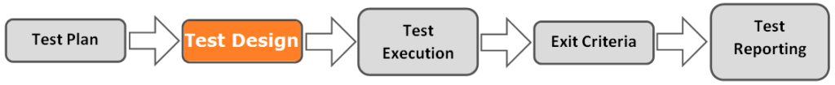](https://www.softwaretestingclass.com/wp-content/uploads/2017/03/test-process-design.png)

Test case (Element in test case document):

* Project / Test title, Test executed by, Test executed date, Version of the software and Test environment
* Test case number
* Test summary
* Steps
* Pre-condition
* Post condition
* Test data
* Actual result
* Expected result
* Test result
* Note

# ****3) Test Execution:****

Manner of executing and test the actual system result against the expected result is test execution. Test execution can be done manually and by using automation suit. During the execution tester needs to make sure, that the user’s need of the software is occupied in the software. Test execution is conducted by referring the document created during test design as step by step process. Tester needs to keep the track while executing the test cases.

[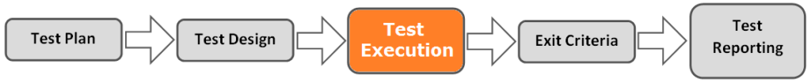](https://www.softwaretestingclass.com/wp-content/uploads/2017/03/test-process-execution.png)

Example for static testing:

* Test the requirement specification document.
* Test the design document
* Test the user guide

Example for dynamic testing:

* Unit testing
* Functional testing
* Integration testing

# ****4) Exit Criteria:****

Exit criteria determines when to stop the test execution. Exit criteria is defined during the test plan phase and used in the test execution phase as a mile stone. Tester needs to set the exit criteria at the beginning, exit criteria may change during the project run as well. There are factors like client need, system stability and filled function that decide the exit criteria. Once the tester reached the exit criteria testing will be stopped. Below are some common exit criteria.

[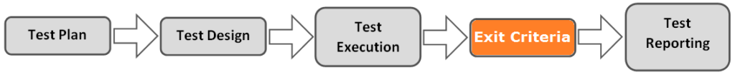](https://www.softwaretestingclass.com/wp-content/uploads/2017/03/test-process-criteria.png)

* All critical defects are closed.
* All the reported defects and closed and verified.
* Executed and covered the areas which used by user mostly.
* System catered all the requirements.
* All the important functions are tested and working as expected.

# ****5) Test Reporting:****

Test reporting gives the picture of test process and result for the particular testing cycle. To define the element in the test reporting the first thing that needs to be considered is whom the audiences of the test report are. For an example a project manager will like to see the high level picture of the testing, intermediate people will wish to view more detail and the client will expect the test reporting in the criteria such as requirement basis, feature basis. Test report is prepared and communicated periodically like daily, weekly, month etc. This needs to be sent in different stages and time.In the future project result of test reports needs to be analysed and apply the lesson learns. Test report contain elements such as test execution status, completed percentage, plan vs. executed test cases, test environment, test execution by resources, risk and mitigation if any, defect summary, test scenario and conditions, any assumption, any note etc.

[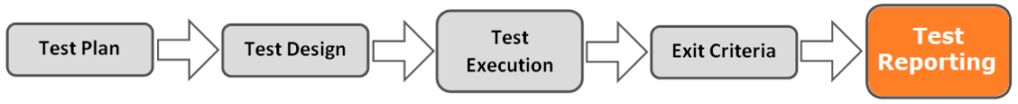](https://www.softwaretestingclass.com/wp-content/uploads/2017/03/test-process-reporting.png)

Test coverage report: (Elements of test coverage report)

* Percentage completed
* Test scenario
* Software area
* Tested resource
* Tested date
* Test result

Defect summary report: (Elements of defect summary report)

* Defect by severity
* Defects by priority
* Defects by assigned developer
* Defects by function
* Defects by software area
* Open and closed defects

Risk and mitigation report: (Elements of risk and mitigation report)

* Identified risk
* Likelihood
* Risk level
* Risk type
* Mitigation plan

## Test Management Tools:

Whether someone wants to track or monitor the process of testing, or wants to identify, understand and mitigate defects from the software product, whatever may be the case, using test management tool is extremely important. These tools can perform several tasks simultaneously and are extremely helpful, as they simplify the process of test management. So, to help you find the best test management tool, here is a list of some of the most popular test management tools.

* ****qTest:**** The best test management tool used by agile testing team, qTest provides easy to learn, easy to use, and scalable test management solutions, which allow easy centralization, organization, and helps in making the process of test management speedy.
* ****PractiTest:**** A flexible and innovative test management tool that offer impeccable customization and seamless integration. Visualize your data using the most advanced dashboards and reports.
* ****QAComplete:**** This is a comprehensive test management tool with enterprise level capabilities. It is extremely easy to use and offers ultimate flexibility to revolutionize your team quality assurance strategies.
* ****Meliora Testlab:**** A powerful test management tool with ALM features. This tool offers excellent assistance during software designing and testing phase and is extremely easy to use. With Meliora TestLab plan, track, and proactively manage manual, automated, and API tests in one repository to mitigate risks.